Reviews website requirements

Functionality

Headers/Footers
Displayed on each page contain following information

Header
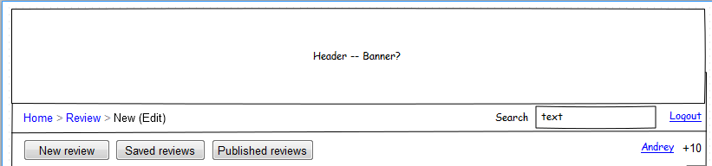
- Header banner (should be designed)
- Navigation header with breadcrumbs
  - Breadcrumbs
    - Home
      - Products
        - Categories
      - My reviews (only if logged in)
        - Add new
Point to add new review page
        - Saved
Point to the list of saved reviews (not published)
        - Published
Point to the list of Published reviews
      - Coupons (to be added in a later stage)
        - Categories
  - Search box
Site search
  - Login/Logout link
Points to login (if user is logged in, points to log out) page
- Member’s navigation (only if logged in see Add review mockup)
  - Add review link/button
Points to add review screen
  - Saved reviews
Point to the list of all saved (unpublished) reviews
  - Published reviews
Point to the list of all saved (unpublished) reviews
  - Link to profile
Point to the profile page
  - Personal rating
Displays current personal rating

Footer
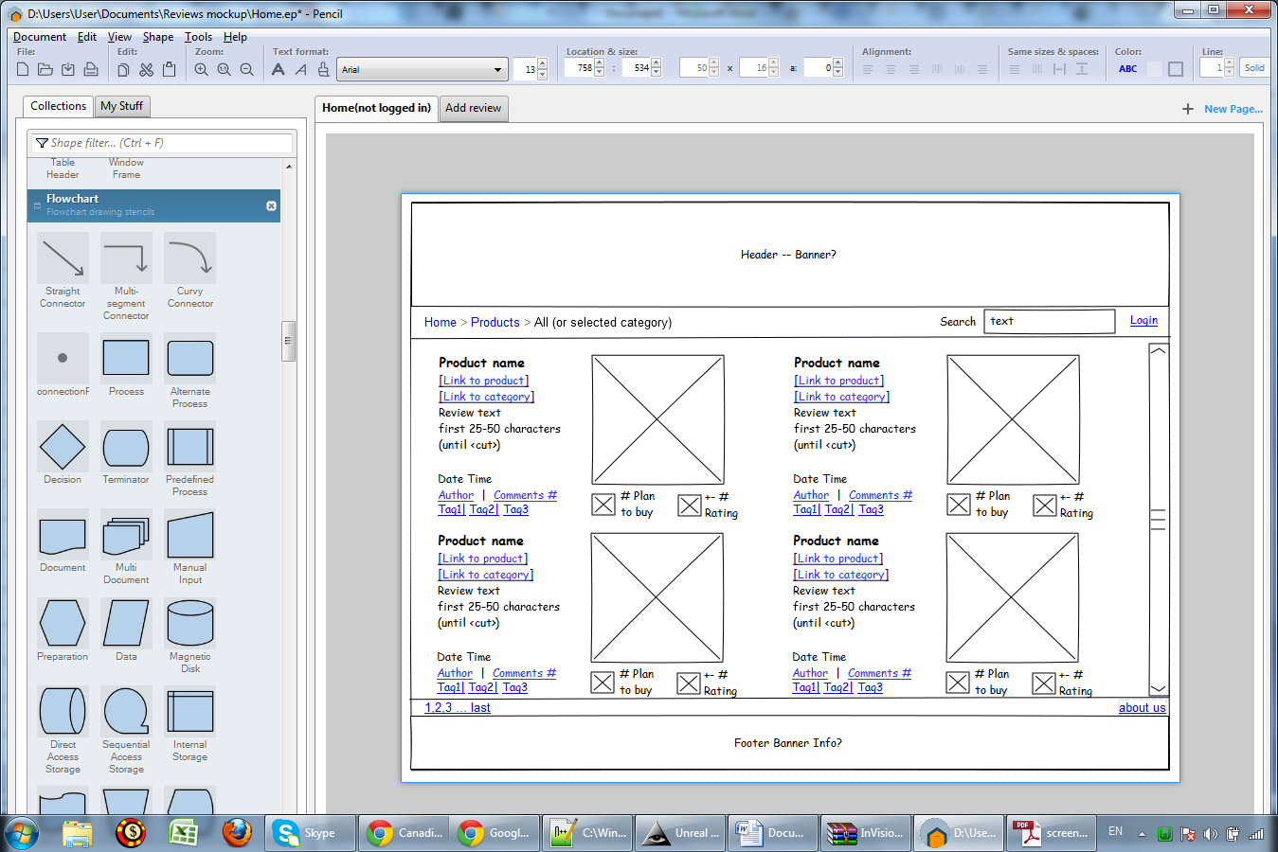
- Footer links and pagination
  - Pagination (if page contains list of reviews)
  - Link to about us page
- Footer banner (should be designed)

Home page
Home page should display following items:

- Reviews
  - Title link
Points to the view review page
  - Image
Clicking on image should get to the view review page
  - Link to product
Points to the product in online store
  - Link to category
Points to the filtered list of reviews with the same category
  - First 50(to be confirmed) characters of text (text before ‘more’ tag)
  - Date time of creation
  - Author link
Link points to the Author’s profile
  - Comments: [Number of comments]
Points to comments section of the review
  - Tags
Points to the filtered list of reviews with the same tag
  - Image plan to buy (to be designed)
Clicking on the image increases number next to it.
Only one time per logged in user; If user is not logged in or already clicked should give a warning.
  - Number of people clicked plan to buy
  - Image Review rating (to be designed)
Clicking on the image rating(number next to it).
Rating can be changed only one time per logged in user per review; if user is not logged in or already clicked should give a warning
  - Review rating
Number of clicks on Like – number of clicks on Dislike

Add/Edit review
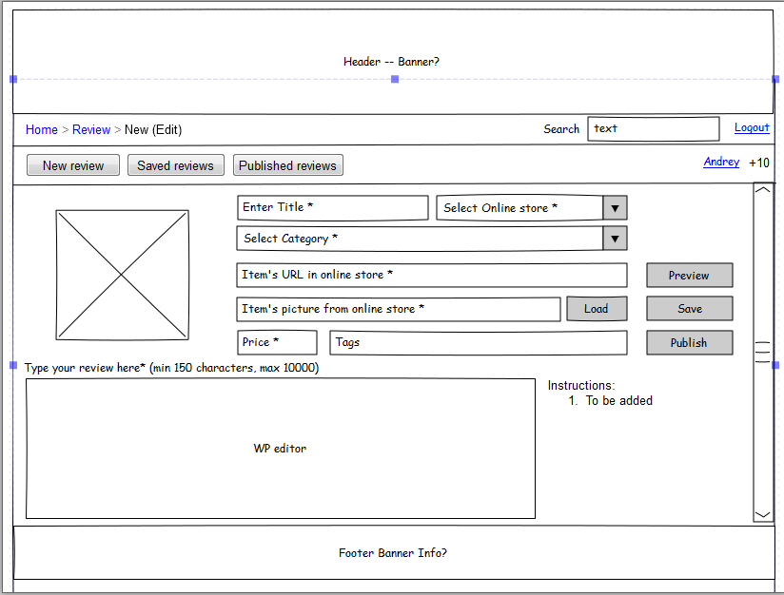
Add/Edit page allow adding editing reviews and contains following fields:
- Product image
Updated once “load” button next to “Item’s picture URL field..” is clicked
- Select online store combo box
Mandatory field
Values taken from database table which is maintained by admin
- Product/Review title text box
Mandatory field
Min 2 characters max 50(to be adjusted) characters
- Category
Mandatory field
Values taken from database table which is maintained by admin
- Item’s URL in online store text box
Mandatory field
Min 2 characters max 150(to be adjusted) characters
- Item’s picture URL from online store textbox
Min 2 characters max 150(to be adjusted) characters
- Load button
Updates picture box on the left hand side loading the image to the website and uploading it to the box (AJAX?)
- Price text box
Mandatory field
Accepts only numerical value greater than .01 lower than 100000
- Tags text box
Accepts only literal and “,” as separator
- Preview button
Preview post before publishing
- Save button
Save post to the drafts (don’t publish)
- Publish button
Validate all fields if everything is fine, proceed with publishing. If not, display hints which fields are not passing validation
- Rich text editor
Editor that would allow enter and format text as well as pasting pictures
- Instructions
Static text will be provided later

View review
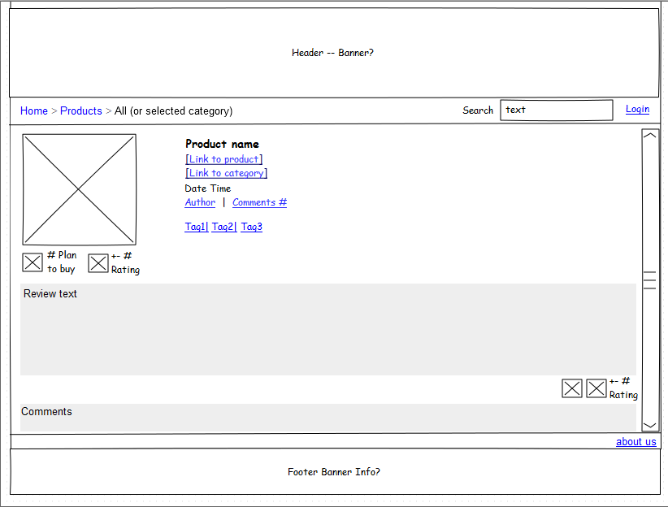

  - Title
  - Image
  - Link to product
Points to the product in online store
  - Link to category
Points to the filtered list of reviews with the same category
  - Author link
Link points to the Author’s profile
  - Comments: [Number of comments]
Points to the comments section of the review
  - Tags
Points to the filtered list of reviews with the same tag
  - Image plan to buy (to be designed)
Clicking on the image increases number next to it.
Only one time per logged in user; If user is not logged in or already clicked should give a warning.
  - Number of people clicked plan to buy
  - Image Review rating (to be designed)
Clicking on the image rating(number next to it).
Rating can be changed only one time per logged in user per review; If user is not logged in or already clicked should give a warning.
  - Review rating
Number of clicks on like – number of clicks on Dislike
  - Review text
  - Like image (should be designed: thumb up?)
Clicking on the image rating (number next to it)
Rating can be changed only one time per logged in user per review; If user is not logged in or already clicked should give a warning.
  - Dislike image (should be designed: thumb down?)
Clicking on the image rating (number next to it)
Rating can be changed only one time per logged in user per review; if user is not logged in or already clicked should give a warning
  - Review rating: +- rating
  - Comments section
Only logged in users can comment
Comments should be have replies hierarchy and rating (like/dislike buttons)

Ratings
- Comment rating
Each comment can be liked/disliked by a logged in user. Rating is displayed next to each comment and defined by number of likes – number of dislikes
- Review rating
Each review (post) can be liked/disliked by a logged in user. Rating is defined by number of likes – number of dislikes
- Author/user rating
Each time user’s comment or review is liked or disliked user’s rating increases/decreases

User membership/administration
Following groups should be supported:
Viewer (Unauthorized),
- Read only access
- Can’t comment
- Can’t post reviews
- Can’t like/dislike reviews and comments
- Can register to become author
Author
- Can post reviews
- Can delete/edit own reviews
- Can post comments
- Can like/dislike reviews and posts
- Can increase plan to buy counter
Admin
- User management console (add/delete users)
- Can add/delete/edit all reviews
- Can add/delete/edit all comments

Design
- Stylish and simplistic approach should be taken. Color scheme preferably white/gray/black
- Header/Footer banners have to be designed/found
- Header banner should include site name ➔ pros and cons reviews
- Plan to buy small image should be designed/found (shopping cart?)
- Rating Up/Down image should be designed/found (thumb up/down?)
- All references to word press should be removed/replaced (logo, about us, etc...)

